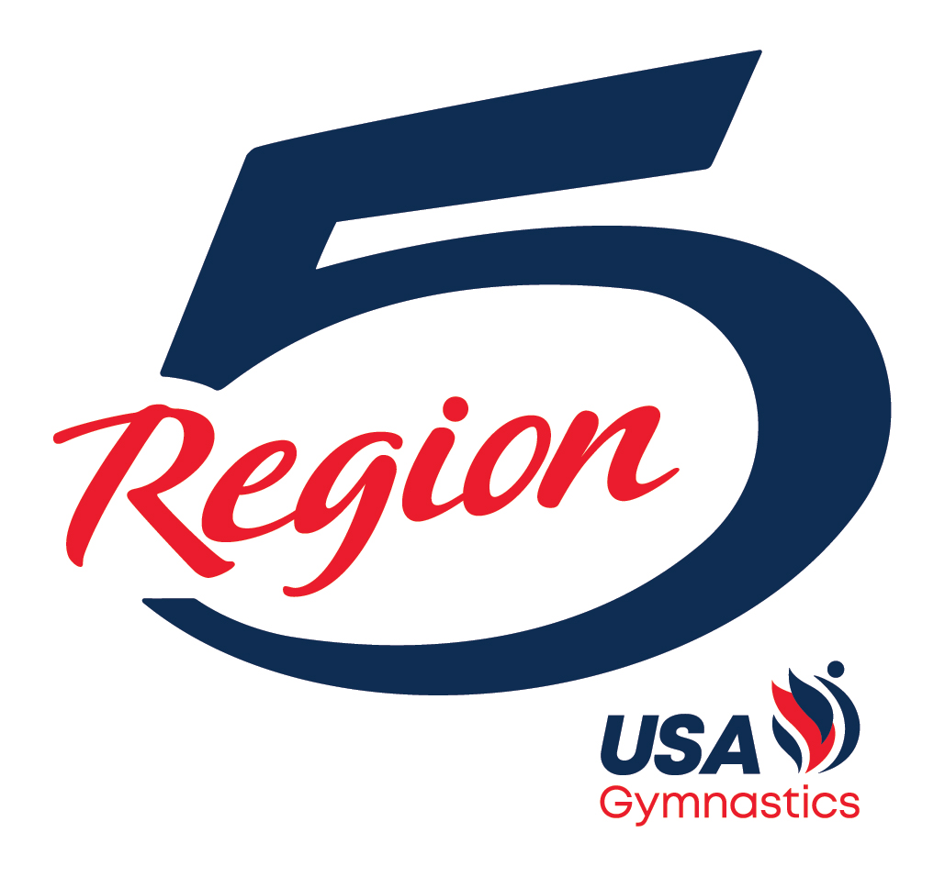

REGION 5
2024 LEVEL 9
EASTERN CHAMPIONSHIPS HANDBOOK

Website: Region5.com
Region 5 Gymnastics Insider

TABLE OF CONTENTS

Page 3 Region 5 Committee Contact Information
Page 4 Welcome Letter
Page 4 Athlete Registration
Page 5 Apparel
Page 6 Etiquette/Curfew
Page 6 Level 9 Easterns Schedule
Page 7 Travel and Hotels
Page 8 Venue
Page 9 Level 9 Easterns Checklist
Page 10 Gymnasts – What to Wear
Page 11 Coaches – What to Wear

Region 5 Committee Contact Information

Tami Schaafsma
Region 5 Chairman
Email: tamischaafsma27@gmail.com
Phone: 616-318-6721

Kittia Carpenter
Regional Development Program Chairman
Email: kittiac@buckeyegymnastics.com
Phone: 614-309-0858

Sue Kane
Regional Technical Chairman
Email: suekanegymoh@gmail.com
Phone: 216-407-2383

Norbert Bendixen
Illinois State Chairman
Email: NorbertIL@aol.com
Phone: 847-334-7768

Patrick Hatmaker
Indiana State Chairman
Email: p.g.hatmaker@gmail.com
Phone: 912-484-0661

Katie Haagen
Kentucky State Chairman
Email: lkhaagen@gmail.com
Phone: 859-684-7276

Michelle Kocan
Michigan State Chairman
Email: michkocan@gmail.com
Phone: 989-430-7638

Kristy Fries

Ohio State Chairman
Email: kristy@integritygym.com
Phone: 440-749-1293

Welcome

Congratulations on qualifying for the 2024 Level 9 Eastern Championships (Easterns)!

Athletes who qualify to Easterns are the top 7 All-Arounders in each age group and number 8 is the 1st Alternate. In Region 5 this achievement means more than just qualifying to Easterns, it means you are now part of the Region 5 Dream Team. This is an honor earned. You will now have the opportunity to represent Region 5 at Easterns in Myrtle Beach, SC

The athletes are divided into the following age divisions: Junior or Senior 1/2/3/4/5/6/7/8.

We, Shane Sanders and Michelle Crane, will be acting as the Region 5 travel and apparel coordinators. Our contact information is as follows:

Shane Sanders
Region 5 Travel Coordinator
Email: shane.region5gymnastics@gmail.com
Phone: 847-757-1286 (only to be used at Easterns)

Michelle Crane
Region 5 Apparel Coordinator
Email: fivedreamteam5@gmail.com
Phone: 740-405-9200

Athlete Registration

A qualified athlete is defined as a gymnast that placed 1-7 and will be COMPETING for Region 5 or a gymnast from Region 5 that will be COMPETING for another region. Region 5 will pay the registration fee for ALL qualified athletes who personally attended one of this season’s (2023-2024) Region 5 Training Camps. If the athlete did not attend a Region 5 Training Camp, her club will be responsible for the registration fee.

Gymnasts in the 1st and 2nd alternate positions will not be registered at this time. Registration for these athletes will occur when they are called upon to replace a qualified gymnast who has to withdraw due to illness or injury.

Coaches will register their Qualified Athletes at the Region 5 Championships using the USA Gymnastics reservation system and will provide a print-out of their Club’s athlete registration form to Tami Schaafsma and/or Dave Stiles. Coaches are required to register all of their athletes at the Region 5 Championships no later than the conclusion of the final Level 9 session on Sunday, April 14th.

Apparel

Athletes
All 2024 Easterns qualifiers, including 1st and 2nd alternates, will complete their apparel forms today. All athletes must be prepared to provide their apparel sizes on the required form. All qualified athletes will receive an apparel itinerary. They must bring all of the apparel they received at the
Region 5 Apparel Processing to Myrtle Beach. All Qualified Athletes and traveling 1st Alternates will pick up their GK competition apparel at the GK booth in Myrtle Beach, SC.

Qualified Athlete Eligibility Rules for Free Region 5 Apparel

Athletes who meet the following criteria will receive FREE Region 5 Apparel:
  - The athlete has qualified to Level 9 Easterns by placing 1-7 at the 2024 Region 5 Championships and will compete at Level 9 Easterns
OR
  - The athlete is a 1st Alternate who has committed to attending the 2024 Level 9 Easterns OR
  - The athlete will travel to Myrtle Beach and compete for another region at the 2024 Level 9 Easterns. A Region 5 athlete may compete for another Region if that Region does not have enough athletes competing in a particular age group to fill the qualified spots. USA Gymnastics will then pull alternates from other Regions to fill those spots.
AND
  - The above athlete’s club attended one of this season’s (2023-2024) Region 5 Training Camps. If the above athlete’s club did not attend a Region 5 Training Camp, she will only receive the Region 5 apparel if her club pays a fee to the Region 5 Apparel Fund. The amount of the fee is $200 for ONE qualified athlete or $400 for TWO or MORE qualified athletes. All payments should be made payable to Region 5 USAG and MUST be given to Tami Schaafsma, the Region 5 RACC, at the 2024 Region 5 Championships.

2nd Alternates
The 2nd alternates are invited to attend Level 9 Easterns. The 2nd Alternates will receive all of the apparel at the Region 5 Championships PROVIDED they agree that they will travel to Myrtle Beach if called to replace an athlete. These athletes must attend 2024 Level 9 Easterns to receive Regional 5 Apparel. The 2nd Alternates must meet the same eligibility requirements outlined above (item #4) to receive free apparel from Region 5.

Coaches
All coaches that will be attending the Level 9 Eastern Championships with their qualified athletes are eligible to receive the designated apparel items for FREE only if they worked one of this season’s (2023-2024) Region 5 Training Camps. This will include the Training Day Shirt, Competition Day 1 Shirt, Competition Day 2 Shirt, the Competition Day 3 Shirt and the Region 5 Pennant Jacket. If a coach did not personally work at one of the camps, he/she must purchase the items required to be worn on each day he/she has an athlete competing at Level 9 Easterns.

Please note: if a coach received Region 5 apparel in 2023, he/she will only receive the apparel items that are NOT the same as last year.
Apparel (continued)

Parents
Region 5 will not be bringing anything to the 2024 Level 9 Easterns for you to purchase, so you must shop and pay for your items at the Region 5 Store today.

THE ONLY WAY TO GUARANTEE REGION 5 MERCHANDISE WILL GET TO YOU BEFORE EASTERNS IS TO ORDER AND PAY TODAY AT THE REGION 5 STORE.

Etiquette/Curfew

Etiquette
YOU ARE REGION 5!
- No cursing
- Team first attitude
- Parents are fans, not coaches.

Curfew
These times must be followed, or the athlete will lose their apparel and risk their spot for competition. There are no exceptions.
- All athletes must be in their rooms 30 minutes prior to Lights Out
- Lights Out is defined as in your hotel room and in bed ready to sleep. Parents/Coaches, please plan accordingly.
- Night before Training Day – 10:30 PM (in room) and 11:00 PM (lights out). If a Region 5 athlete is competing for another Region, her curfew may be adjusted based on her Region’s practice time.
- Night before Competition – 9:30 PM (in room) and 10:00 PM (lights out)
- Night after Competition – 11:30 PM (in room) and 12:00 AM/Midnight (lights out)

Level 9 Easterns Schedule
Level 9 Easterns does offer a Training Day for its qualified athletes (1-7 only). This is an optional practice and Region 5 athletes ARE NOT required to attend. If spots are available, 1st Alternates will become eligible to be added to our Training Day roster. More information regarding Training Day will be communicated at a later.

Thursday, May 2, 2024 (Training Day)
Practice time for Region 5 is 10:50 AM to 1:20 PM.

Region 5 athletes may pick up their GK apparel at the GK Booth before or after practice. 2nd Alternates do not!

Level 9 Easterns Schedule (continued)

Friday, May 3, 2024 – Competition Day 1
Junior 1 & 2 - 8:00 AM
Junior 3 & 4 - 12:30 PM
Junior 5 & 6 - 5:00 PM

Saturday, May 4, 2024 – Competition Day 2
Junior 7 & 8 - 8:00 AM
Senior 1 & 2 - 12:30 PM
Senior 3 & 4 - 5:00 PM

Sunday, May 5, 2024 – Competition Day 3
Senior 5 & 6 – 8:00 AM
Senior 7 & 8 – 12:30 PM

Region 5 athletes who do not attend the Thursday practice session may pick up their GK competition apparel any time before their scheduled competition time. The GK Booth will be open Thursday – Saturday from 8:00 AM to 8:00 PM and on Sunday from 8:00 AM to 12:00 PM. 2nd Alternates will only receive their GK Apparel when they are called to replace a competing athlete.

Travel and Hotels

Flights:
Region 5 will not be making any flight arrangements for our athletes going to Level 9 Easterns. It is the responsibility of the gymnast’s parents or club to make these arrangements.

Hotel:
USA Gymnastics has arranged a room block at a variety of hotels in Myrtle Beach. You can access the hotel link at usagym.org/events/2024-womens-development-program-level-9-eastern-championships/

All parents and coaches attending the 2024 Level 9 Easterns will be required to complete a Contact Information Form. It is the responsibility of the parents and coaches to make own their hotel arrangements.

Venue
Level 9 Easterns is being held at the Myrtle Beach Sports Center. The address is:
2115 Sports Center Way
Myrtle Beach, SC 29577

Region 5 Webpage:
All pertinent information regarding our stay in Myrtle Beach will be posted on the Region 5 webpage at www.region5.com/eastern-nationals.

Once again, congratulations on qualifying to the 2024 Level 9 Eastern Championships! Over the next few weeks, remember to train hard, remain focused on the task before you and stay healthy.

GO REGION 5!

2024 LEVEL 9 EASTERNS
CHECK LIST

BEFORE LEAVING REGIONALS
□ Parent/Coach Contact Information and Publicity Release Form – Shane Sanders
□ Athlete/Coach Registration – Dave Stiles
□ Athlete/Coach Apparel Processing – Michelle Crane
□ Region 5 Insider – Jason MacDonald
□ Shop at the Region 5 Store

DAY AFTER
□ Book travel arrangements
□ Hotel (try to make hotel reservations today!)
□ Flight/Car

AFTER MAY 1ST
□ Pack according to list
□ Athletes/Parents/Coaches review your travel itineraries
□ Coaches make sure digital copies of floor music is DOWNLOADED onto electronic devices
.

Level 9 Easterns 2024
GYMNASTS – What to Wear!!

Congratulations on making the 2024 Level 9 Easterns.
Each day we will look like a TEAM! Here is what to wear each day and what to bring. ALL questions should be directed to Michelle Crane via email at fivedreamteam5@gmail.com

TRAVEL DAY:
Grey “On Fire” T-Shirt
Your choice of your own pants with NO visible rips or holes

TRAINING DAY:
Black Tank Top
GK Tank Leotard you received at Processing

COMPETITION DAY:
GK Competition Tank Leotard - Received at Easterns
GK Warm Up – Received at Easterns
Red Light Up Glasses
Tattoo – Received at Easterns

Hair & Make-up are your choice. Your hair should be pulled back in either a bun or a ponytail.

Each day bring your Region 5 Sling Bag with grips, chalk, spray bottle for grips, drinking water bottle, hand sanitizer, and any other items you may need with you!

Level 9 Easterns 2024
Coaches – What to Wear!!

Congratulations on qualifying your athlete(s) to the 2024 Level 9 Easterns.
Each day we will look like a TEAM! Here is what to wear each day and what to bring. ALL questions should be directed to Michelle Crane via email at fivedreamteam5@gmail.com

TRAVEL DAY:
Any Region 5 Apparel or the Grey “On Fire” T-Shirt
Your choice of your own pants with NO visible rips or holes
Region 5 Pennant Jacket if needed

TRAINING DAY:
Grey “On Fire” T-Shirt
Black or Red Shorts – your own
Region 5 Pennant Jacket if needed

FRIDAY:
Black T-Shirt with large Region 5 logo
Your own Black or Red Pants
Red Light Up Glasses

SATURDAY:
Black Region 5 Shirt – Logo on left chest
Your own Black, Red or Grey pants
Red Light Up Glasses

SUNDAY:
Red Region 5 shirt – Logo on left chest
Your own Black or Grey pants
Red Light Up Glasses

EACH DAY:
Bring your Pennant Jacket if needed.

If you lack the required “shirt-of-the-day”, please wear a plain short sleeved shirt of the day’s color and the Region 5 Pennant Jacket.

