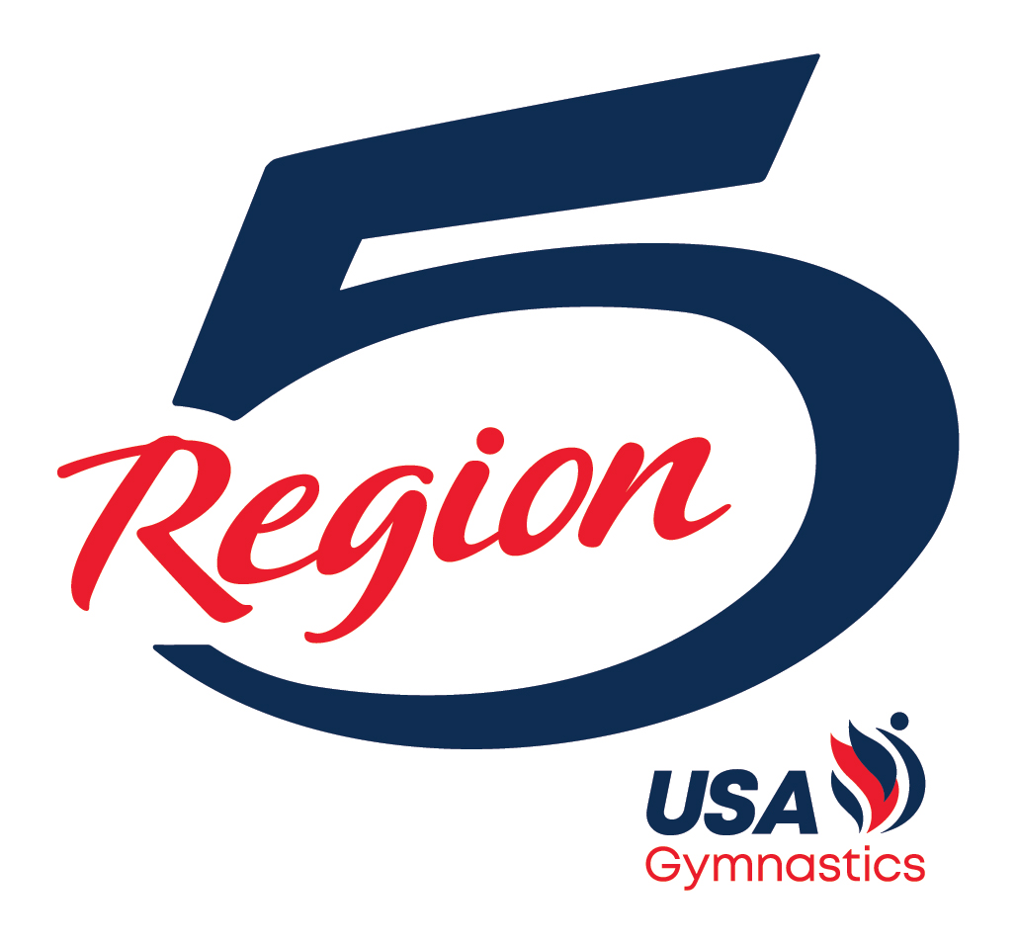

REGION 5
2026 LEVEL 9
EASTERN CHAMPIONSHIPS HANDBOOK

Website: Region5.com
Region 5 Gymnastics Insider

TABLE OF CONTENTS

Page 3 Region 5 Committee Contact Information
Page 4 Welcome Letter
Page 4 Athlete Registration
Page 5 Apparel
Page 6 Etiquette/Curfew
Page 6 Level 9 Easterns Schedule
Page 7 Travel and Hotels
Page 8 Venue
Page 8 Region 5 Webpage
Page 9 Level 9 Easterns Checklist
Page 10 Gymnasts – What to Wear
Page 11 Coaches – What to Wear

Region 5 Committee Contact Information

Tami Schaafsma
Region 5 Chairman
Email: tamischaafsma27@gmail.com
Phone: 616-318-6721

Kittia Carpenter
Regional Development Program Chairman
Email: kittiac@buckeyegymnastics.com
Phone: 614-309-0858

Kathleen Edwards
Regional Technical Chairman
Email: kathleenregion5@gmail.com
Phone: 513-404-4728

Norbert Bendixen
Illinois State Chairman
Email: NorbertIL@aol.com
Phone: 847-334-7768

Patrick Hatmaker
Indiana State Chairman
Email: p.g.hatmaker@gmail.com
Phone: 912-484-0661

Katie Haagen
Kentucky State Chairman
Email: lkhaagen@gmail.com
Phone: 859-684-7276

Michelle Kocan
Michigan State Chairman
Email: michkocan@gmail.com
Phone: 989-430-7638

Kristy Fries

Ohio State Chairman
Email: kristy@integritygym.com
Phone: 440-749-1293

Welcome

Congratulations on qualifying for the 2026 Level 9 Eastern Championships (Easterns)!

Athletes who qualify to Easterns are the top 7 All-Arounders in each age group and number 8 is the 1st Alternate. In Region 5 this achievement means more than just qualifying to Easterns, it means you are now part of the Region 5 Dream Team. This is an honor earned. You will now have the opportunity to represent Region 5 at Easterns in Savannah, GA

The athletes are divided into the following age divisions: Junior or Senior 1/2/3/4/5/6/7/8.

We, Shane Sanders and Michelle Crane, will be acting as the Region 5 travel and apparel coordinators. Our contact information is as follows:

Shane Sanders
Region 5 Travel Coordinator
Email: shane.region5gymnastics@gmail.com
Phone: 847-757-1286

Michelle Crane
Region 5 Apparel Coordinator
Email: fivedreamteam5@gmail.com
Phone: 740-405-9200

Athlete Registration

A qualified athlete is defined as a gymnast that placed 1-7 and will be COMPETING for Region 5 or a gymnast from Region 5 that will be COMPETING for another region. Region 5 will pay the registration fee for ALL qualified athletes who personally attended one of this season’s (2026-2026) Region 5 Training Camps. If the athlete did not attend a Region 5 Training Camp, her club will be responsible for the registration fee.

Gymnasts in the 1st and 2nd alternate positions will not be registered at this time. Registration for these athletes will occur when they are called upon to replace a qualified gymnast who has to withdraw due to illness or injury.

Coaches will register their Qualified Athletes at the Region 5 Championships using the USA Gymnastics reservation system and will provide a print-out of their Club’s athlete registration form to Tami Schaafsma and/or Dave Stiles. Coaches are required to register all of their athletes at the Region 5 Championships no later than the conclusion of the final Level 9 session on Sunday, April 10th.

Apparel

Athletes
All 2026 Easterns qualifiers, including 1st and 2nd alternates, will complete their apparel forms during processing at the Region 5 Championships. All athletes must be prepared to provide their apparel sizes on the required form. All qualified athletes will receive an apparel itinerary. They must bring all of the apparel they received at the Region 5 Apparel Championships to Savannah. All Qualified Athletes and traveling 1st Alternates will pick up their GK competition apparel at the GK booth in Savannah, GA.

Qualified Athlete Eligibility Rules for Free Region 5 Apparel

Athletes who meet the following criteria will receive FREE Region 5 Apparel:
  - The athlete has qualified to Level 9 Easterns by placing 1-7 at the 2026 Region 5 Championships and will compete at Level 9 Easterns
OR
  - The athlete is a 1st Alternate who has committed to attending the 2026 Level 9 Easterns OR
  - The athlete will travel to Savannah and compete for another region at the 2026 Level 9 Easterns. A Region 5 athlete may compete for another Region if that Region does not have enough athletes competing in a particular age group to fill the qualified spots. USA Gymnastics will then pull alternates from other Regions to fill those spots.
AND
  - The above athlete’s club attended one of this season’s (2025-2026) Region 5 Training Camps. If the above athlete’s club did not attend a Region 5 Training Camp, she will only receive the Region 5 apparel if her club pays a fee to the Region 5 Apparel Fund. The fee is $200 for ONE qualified athlete or $400 for TWO or MORE qualified athletes. All payments should be made payable to Region 5 USAG and MUST be given to Tami Schaafsma, the Region 5 RACC, at the 2026 Region 5 Championships.

2nd Alternates
The 2nd alternates are invited to attend Level 9 Easterns. The 2nd Alternates WILL NOT receive any Region 5 Apparel until they are called to replace an athlete. These athletes must attend 2026 Level 9 Easterns to receive Regional 5 Apparel. The 2nd Alternates must meet the same eligibility requirements outlined above (item #4) to receive free apparel from Region 5. Arrangements will be made to deliver the Region 5 Apparel to the 2nd Alternate once she confirms her acceptance as a replacement athlete.

Coaches
All coaches that will be attending the Level 9 Eastern Championships with their qualified athletes are eligible to receive the designated apparel items for FREE only if they worked one of this season’s (2025-2026) Region 5 Training Camps. This will include the Training Day Shirt, Competition Day 1 Shirt, Competition Day 2 Shirt, the Competition Day 3 Shirt and the Region 5 Pennant Jacket. If a coach did not personally work at one of the camps, he/she must purchase the items required to be worn on each day he/she has an athlete competing at Level 9 Easterns.

Apparel (continued)

Parents
Region 5 will not be bringing anything to the 2026 Level 9 Easterns for you to purchase, so you must shop and pay for your items at the Region 5 Store today.

THE ONLY WAY TO GUARANTEE REGION 5 MERCHANDISE WILL GET TO YOU BEFORE EASTERNS IS TO ORDER AND PAY TODAY AT THE REGION 5 STORE.

Etiquette/Curfew

Etiquette
YOU ARE REGION 5!
- No cursing
- Team first attitude
- Parents are fans, not coaches.

Curfew
Parents are strongly encouraged to ensure their daughters abide by the Region 5 curfew guidelines while at Level 9 Easterns. These guidelines are in place so that our athletes are well rested and prepared for competition.
- All athletes must be in their rooms 30 minutes prior to Lights Out
- Lights Out is defined as in your hotel room and in bed ready to sleep. Parents/Coaches, please plan accordingly.
- Night before Training Day – 9:30 PM (in room) and 10:00 PM (lights out).
- Night before Competition – 9:30 PM (in room) and 10:00 PM (lights out)
- Night after Competition – 11:30 PM (in room) and 12:00 AM/Midnight (lights out)

Level 9 Easterns Schedule
Level 9 Easterns does offer a Training Day for its qualified athletes (1-7 only). This is an optional practice and Region 5 athletes ARE NOT required to attend. If spots are available, 1st Alternates will become eligible to be added to our Training Day roster. More information regarding Training Day will be communicated at a later date.

Thursday, April 30, 2026 (Training Day)
Practice time for Region 5 is 4:00 PM to 6:30 PM. Coaches and gymnasts should plan on arriving 30 minutes in advance of our training time.

Region 5 athletes may pick up their GK apparel at the GK Booth before practice. 1st Alternates must be present at Level 9 Easterns to receive their GK apparel. 2nd Alternates will not receive their GK apparel until they are called up as a replacement athlete and are present at Level 9 Easterns

Level 9 Easterns Schedule (continued)

Friday, May 1, 2026 – Competition Day 1
Junior 1 & 2 - 8:00 AM
Junior 3 & 4 - 12:30 PM
Junior 5 & 6 - 5:00 PM

Saturday, May 2, 2026 – Competition Day 2
Junior 7 & 8 - 8:00 AM
Senior 1 & 2 - 12:30 PM
Senior 3 & 4 - 5:00 PM

Sunday, May 3, 2026 – Competition Day 3
Senior 5 & 6 – 8:00 AM
Senior 7 & 8 – 12:30 PM

Region 5 athletes who do not attend the Thursday practice session may pick up their GK competition apparel any time before their scheduled competition time. The GK Booth will be open Thursday – Saturday from 8:00 AM to 6:00 PM and on Sunday from 8:00 AM to 12:00 PM. 2nd Alternates will only receive their GK Apparel when they are called to replace a competing athlete.

Travel and Hotels

Flights:
Region 5 will not be making any flight arrangements for our athletes going to Level 9 Easterns. It is the responsibility of the gymnast’s parents or club to make these arrangements.

Hotel:
Coaches and Parents will make their own hotel arrangements. USA Gymnastics has arranged a room block at a variety of hotels in Savannah. You can access the hotel link at usagym.org/events/2026-womens-development-program-level-9-eastern-championships/

There are also other hotels in the area to choose from if the USA Gymnastics room block does not meet your travel needs.

All parents and coaches attending the 2026 Level 9 Easterns will be required to complete a Contact Information Form. It is the responsibility of the parents and coaches to make their own hotel arrangements.

Venue
Savannah Convention Center
1 International Drive
Savannah, GA 31421

Region 5 Webpage:
All pertinent information regarding our stay in Savannah will be posted on the Region 5 webpage at www.region5.com/eastern-nationals.

Once again, congratulations on qualifying for the 2026 Level 9 Eastern Championships! Over the next few weeks, remember to train hard, remain focused on the task before you and stay healthy.

GO REGION 5!

2026 LEVEL 9 EASTERNS
CHECK LIST

BEFORE LEAVING REGIONALS
□ Parent/Coach Contact Information and Publicity Release Form – Shane Sanders
□ Athlete/Coach Registration – Dave Stiles
□ Athlete/Coach Apparel Processing – Michelle Crane
□ Region 5 Insider – Jason MacDonald
□ Shop at the Region 5 Store

DAY AFTER
□ Book travel arrangements
□ Hotel (try to make hotel reservations today!)
□ Flight/Car

AFTER
□ Pack according to list
□ Athletes/Parents/Coaches review your travel itineraries
□ Coaches make sure digital copies of floor music is DOWNLOADED onto electronic devices
.

2026 Level 9 Easterns
Gymnasts – What to Wear

Congratulations on making the 2026 Level 9 Easterns.
Each day we will look like a TEAM! Here is what to wear each day and what to bring. ALL questions should be directed to Michelle Crane via email at fivedreamteam5@gmail.com

TRAVEL DAY:
Heather Pink T-shirt
Pink Hoodie
Your choice of pants

TRAINING DAY:
GK Tank Leotard – You got at Regionals during processing
Gray T- shirt
Your choice of pants and jacket if needed
Region 5 Pink Crossbody

COMPETITION DAY:
GK Tank Competition Leotard – Pick up at Nationals
GK Warm Up – Pick up at Nationals
Pink Light Up Glasses
Tattoo – Left cheek
Region 5 Pink Crossbody
Hair should be in a ponytail or a bun

NON-COMPETITION DAY:
Any Region 5 apparel you have. You can purchase more at the Regionals also.

2026 Level 9 Easterns
Coaches – What to Wear

Congratulations on qualifying your athlete(s) for the 2026 Level 9 Easterns.
Each day we will look like a TEAM! Here is what to wear each day and what to bring. ALL questions should be directed to Michelle Crane via email at fivedreamteam5@gmail.com

Travel Day / Training Day: Thursday
Heather Pink T-shirt
Your choice of pants
Region 5 Quarter Zip if needed

FRIDAY: Day 1 competition
Gray T shirt
Black / Gray / Pink pants
Region 5 Quarter Zip if needed

SATURDAY: Day 2 competition
Black Circle Logo T shirt
Black / Gray / Pink pants
Region 5 Quarter Zip if needed

SUNDAY: Day 3 competition
White T Shirt
Black / Gray / Pink pants
Region 5 Quarter Zip if needed

If you lack the required “shirt-of-the-day”, please wear a plain short sleeved shirt of the day’s color and the Region 5 Quarter Zip Jacket.

